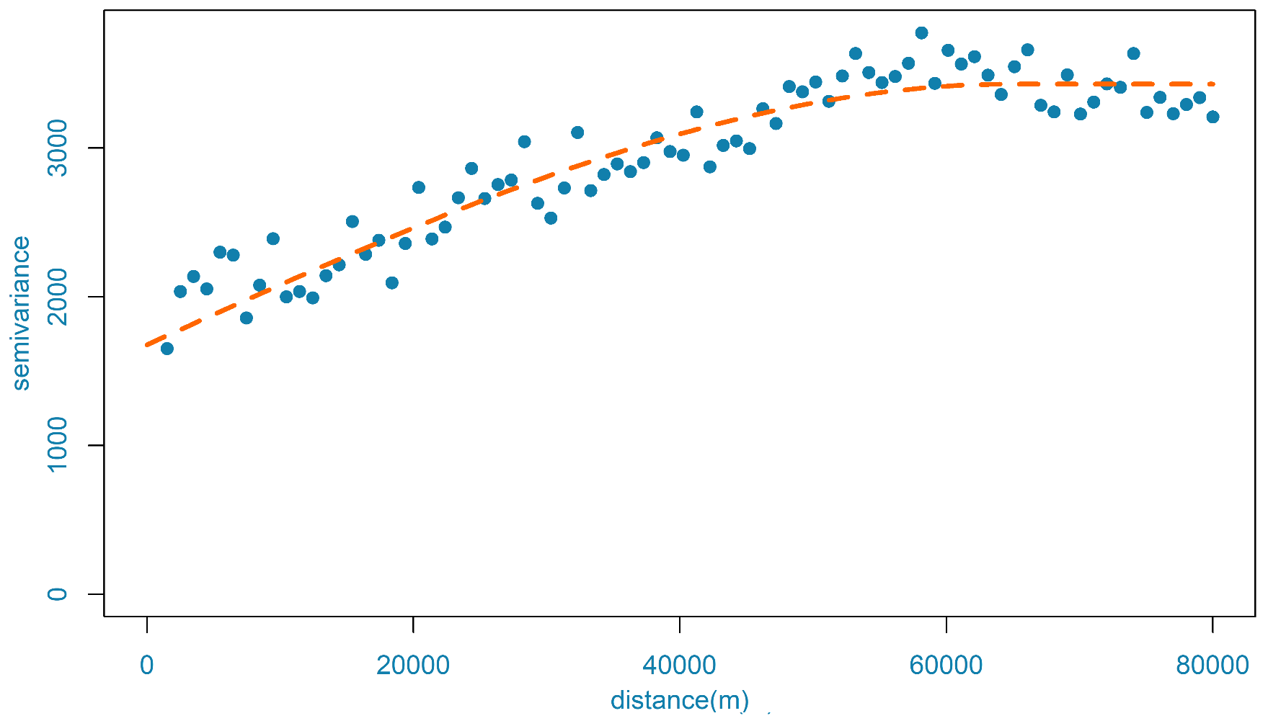

**Nugget = 1667**

**Sill = 3419**

**Range = 60000 m**